LAB MANUAL OF SOFTWARE ENGINEERING LAB

ETCS 353



## Maharaja Agrasen Institute of Technology, PSP area,

Sector – 22, Rohini, New Delhi – 110085

## ( Affiliated to Guru Gobind Singh Indraprastha University, New Delhi )



### MAHARAJA AGRASEN INSTITUTE OF TECHNOLOGY VISION

To nurture young minds in a learning environment of high academic value and imbibe spiritual and ethical values with technological and management competence.

### MISSION

The Institute shall endeavor to incorporate the following basic missions in the teaching methodology:

**Engineering Hardware – Software Symbiosis**

Practical exercises in all Engineering and Management disciplines shall be carried out by Hardware equipment as well as the related software enabling deeper understanding of basic concepts and encouraging inquisitive nature.

**Life – Long Learning**

The Institute strives to match technological advancements and encourage students to keep updating their knowledge for enhancing their skills and inculcating their habit of continuous learning.

**Liberalization and Globalization**

The Institute endeavors to enhance technical and management skills of students so that they are intellectually capable and competent professionals with Industrial Aptitude to face the challenges of globalization.

**Diversification**

The Engineering, Technology and Management disciplines have diverse fields of studies with different attributes. The aim is to create a synergy of the above attributes by encouraging analytical thinking.

**Digitization of Learning Processes**

The Institute provides seamless opportunities for innovative learning in all Engineering and Management disciplines through digitization of learning processes using analysis, synthesis, simulation, graphics, tutorials and related tools to create a platform for multi-disciplinary approach.

**Entrepreneurship**

The Institute strives to develop potential Engineers and Managers by enhancing their skills and research capabilities so that they become successful entrepreneurs and responsible citizens.



**MAHARAJA AGRASEN INSTITUTE OF TECHNOLOGY**

**COMPUTER SCIENCE & ENGINEERING DEPARTMENT**

**VISION**

To Produce “Critical thinkers of Innovative Technology”

### MISSION

To provide an excellent learning environment across the computer science discipline to inculcate professional behavior, strong ethical values, innovative research capabilities and leadership abilities which enable them to become successful entrepreneurs in this globalized world.

1. To nurture an **excellent learning environment** that helps students to enhance their problem solving skills and to prepare students to be lifelong learners by offering a solid theoretical foundation with applied computing experiences and educating them about their **professional, and ethical responsibilities**.
2. To establish **Industry-Institute Interaction**, making students ready for the industrial environment and be successful in their professional lives.
3. To promote **research activities** in the emerging areas of technology convergence.
4. To build engineers who can look into technical aspects of an engineering solution thereby setting a ground for producing successful **entrepreneur.**

# INDEX OF THE CONTENTS

#### Introduction to the lab

1. **Lab Requirements (details of H/W & S/W to be used)**

#### List of Experiments as per GGSIPU

1. **List of experiments beyond the syllabus**

#### Format of the lab record to be prepared by the students.

1. **Marking scheme for the Practical Exam**
2. **Instructions for each Lab Experiment**

# INTRODUCTION TO THE LAB

**Lab Objective:** The Software Engineering Lab has been developed to impart state-of-the-art knowledge on Software Engineering practical aspects and UML in an interactive manner. This course also provide scope to students where they can solve small, real life problems and present case studies, can further demonstrate practical applications of different concepts.

#### Course Outcomes

At the end of the course, a student will be able to:

1. To elicit, analyse and specify software requirements of given problem statement.
2. Analyse and translate a specification in to a function oriented diagram.
3. To perform user’s view analysis and structural view analysis of system.
4. To draw behavioural view of system.
5. To build implementation and environmental view of system.
6. Create the test cases in accordance with the testing plan and to verify and validate the implementation of the software specifications.

# LAB REQUIREMENTS

|  |
| --- |
| **H/W Detail** |
| Intel i3/C2D Processor/2 GB RAM/500GB HDD/MB/Lan Card/  Key Board/ Mouse/CD Drive/15” Color Monitor/ UPS 24 Nos |
| LaserJet Printer 1 No |
| **S/W Detail** |

Fedora Linux, StarUML

# LIST OF EXPERIMENTS (As prescribed by G.G.S.I.P.U)

1. Write down the problem statement for a suggested system of relevance.
2. Do requirement analysis and develop Software Requirement Specification Sheet (SRS) for suggested system.
3. To perform the function oriented diagram: Data Flow Diagram (DFD) and Structured chart.
4. To perform the user’s view analysis for the suggested system: Use case diagram.
5. To draw the structural view diagram for the system: Class diagram, object diagram.
6. To draw the behavioral view diagram: State-chart diagram, Activity diagram
7. To perform the behavioral view diagram for the suggested system: Sequence diagram, Collaboration diagram
8. To perform the implementation view diagram: Component diagram for the system.
9. To perform the environmental view diagram: Deployment diagram for the system.
10. To perform various testing using the testing tool unit testing, integration testing for a sample code of the suggested system.
11. To Perform Estimation of effort using FP Estimation for chosen system.
12. To Prepare time line chart/Gantt Chart/PERT Chart for selected software project. NOTE: - At least 8 Experiments out of the list must be done in the semester.

Choose any one project and do the above exercises for that project

1. Student Result Management System
2. Library management system
3. Inventory control system
4. Accounting system
5. Fast food billing system
6. Bank loan system
7. Blood bank system
8. Railway reservation system
9. Automatic teller machine
10. Video library management system
11. Hotel management system
12. Hostel management system
13. E-ticking
14. Share online trading
15. Hostel management system
16. Resource management system
17. Court case management system

# 4.LIST OF EXPERIMENTS

**(Beyond the syllabus)**

* 1. To design a flow chart for chosen system.
  2. To draw ER Diagram for chosen system.

# FORMAT OF THE LAB RECORD TO BEPREPARED BY THE STUDENTS

The front page of the lab record prepared by the students should have a cover page as displayed below.

***NAME OF THE LAB***

***Paper Code***

Font should be (Size 20”, italics bold, Times New Roman)

Faculty name Student name

Roll No.: Semester:

Font should be (12”, Times Roman)



## Maharaja Agrasen Institute of Technology, PSP Area, Sector – 22, Rohini, New Delhi – 110085

Font should be (18”, Times Roman)

**INDEX**

|  |  |  |  |  |  |
| --- | --- | --- | --- | --- | --- |
| Exp. no | Experiment Name | Date of performance | Date of checking | Remarks | Marks |
|  |  |  |  |  |  |
|  |  |  |  |  |  |
|  |  |  |  |  |  |
|  |  |  |  |  |  |
|  |  |  |  |  |  |
|  |  |  |  |  |  |
|  |  |  |  |  |  |

* + 1. **MARKING SCHEME FOR THE PRACTICAL**

**EXAMS**

There will be two practical exams in each semester.

* + - 1. Internal Practical Exam
      2. External Practical Exam

##### INTERNAL PRACTICAL EXAM

It is taken by the respective faculty of the batch.

**MARKING SCHEME FOR THIS EXAM IS**:

Total Marks: 40

Division of 10 marks per practical is as follows:

|  |  |  |  |  |
| --- | --- | --- | --- | --- |
|  | **Rubrics for : Laboratory (General)** | | | |
| Sr No. | Experiment Component (LAC) | Max. Marks | Grading Rubrics | |
| 2 marks | 1 mark |
| 1 | Practical Performance | 2 | Completeness of practical, exhibits proficiency in using different types of inputs. | Incomplete practical, unformatted, lacks comments, Demonstrates no proficiency. |
| 2 | Output and Validation | 2 | Output is free of errors and output is obtained.  Demonstrates excellent understanding of the concepts relevant to the experiment. | Output contains few logical errors and/or no output is obtained. Demonstrates partial understanding of the concepts relevant to the experiment. |
| 3 | Attendance and Viva Questions Answered | 4 | 1. Four marks for answering more than 75% questions. 2. Two marks for answering more then 50% questions. 3. One mark for answering less then 50% questions. | |
| 4 | Timely Submission of Lab Record | 2 | On time submission | Late submission |

Each experiment will be evaluated out of 10 marks. At the end of the semester average of 8 best performed practical will be considered as marks out of 40.

##### EXTERNAL PRACTICAL EXAM

It is taken by the concerned lecturer of the batch and by an external examiner. In this exam student needs to perform the experiment allotted at the time of the examination, a sheet will be given to the student in which some details asked by the examiner needs to be written and at the last viva will be taken by the external examiner.

**MARKING SCHEME FOR THIS EXAM IS**:

Total Marks: 60

Division of 60 marks is as follows

|  |  |
| --- | --- |
| 1. Sheet filled by the student: | 20 |
| 2. Viva Voice: | 15 |
| 3. Experiment performance: | 15 |
| 4. File submitted: | 10 |

**NOTE:**

* Internal marks + External marks = Total marks given to the students

(40 marks) (60 marks) (100 marks)

* Experiments given to perform can be from any section of the lab.

# INSTRUCTIONS FOR EACH LAB EXPERIMENT

### INTRODUCTION TO STAR UML

StarUML is an open source software modeling tool that supports UML (Unified Modeling Language). It is based on UML version 1.4, provides eleven different types of diagram and it accepts UML 2.0 notation. It actively supports the MDA (Model Driven Architecture) approach by supporting the UML profile concept and allowing to generate code for multiple languages.

##### Features

When you start a new project, StarUML proposes which approach you want to use: 4+1 (Krutchen), Rational, UML components (from Chessman and Daniels book), default or empty. Depending on the approach, profiles and/or frameworks may be included and loaded. If you don't follow a specific approach, the "empty" choice could be used. Although a project can be managed as one file, it may be convenient to divide it into many units and manage them separately if many developers are working on it together.

StarUML makes a clear conceptual distinction between models, views and diagrams. A Model is an element that contains information for a software model. A View is a visual expression of the information contained in a model, and a Diagram is a collection of view elements that represent the user’s specific design thoughts.

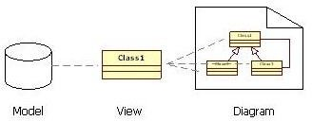

StarUML is build as a modular and open tool. It provides frameworks for extending the functionality of the tool. It is designed to allow access to all functions of the model/meta-model and tool through COM Automation, and it provides extension of menu and option items. Also, users can create their own approaches and frameworks according to their methodologies. The tool can also be integrated with any external tools.

The user interface is intuitive. On the upper right side, a window allows to rapidly navigate between all the content of a project, adopting either a model or a diagram view. Multiple diagrams can be open at the same time and tabs allow switching rapidly between views. The lower right window allows to document the current diagram, either with plain text or attaching an external document. During diagram editing, "wizards" are located around the object that give you the quick shortcuts to main associated tasks with your current operation, like adding an attribute when you create a class for instance. A right-click on the mouse brings the full set of operations at your disposal.

StarUML has also a model verification feature. You can export diagram in different formats (jpg, bmp, wmf). It also supports a patterns approach and import of Rational Rose files.

StarUML Generator is platform module to generate various artifacts (like as Microsoft Word, Excel, PowerPoint, and Text-based artifacts) by templates depending on UML model elements in StarUML. The users can define their own templates and can apply many different kinds of templates to the same UML model, so the users can get various artifacts automatically, easily and fast. The tool supports code generation and reverse engineering for Java, C# and C++.

### Experiment 1.

**Aim:** Write down the problem statement for a suggested system of relevance.

**Description:** The problem statement is the initial starting point for a project. It is basically a one to three-page statement that everyone on the project agrees with that describes what will be done at a high level. The problem statement is intended for a broad audience and should be written in non-technical terms. It helps the non-technical and technical personnel communicate by providing a description of a problem. It doesn't describe the solution to the problem.

The input to requirement engineering is the problem statement prepared by customer.

It may give an overview of the existing system along with broad expectations from the new system.

The first phase of requirements engineering begins with requirements elicitation i.e. gathering of information about requirements. Here, requirements are identified with the help of customer and existing system processes. So from here begins the preparation of problem statement.

So, basically a problem statement describes **what** needs to be done without describing **how**.

#### Performance Instruction:

1. Choose any one project from given list.
2. Collect all requirements
3. Identify functionalities
4. Write a one to three-page statement that everyone on the project agrees with that describes what will be done at a high level.

#### Sample Output:

##### PROBLEM STATEMENT FOR RAILWAY RESERVATION SYSTEM

Software has to be developed for automating the manual railway reservation system. The system should be distributed in nature. It should be designed to provide the functionalities as follows:

1. **Reserve Seat:** A traveler should be able to reserve seats in the desired train. A reservation form is to be filled by the traveler and given to the clerk, who then checks for the availability of seats for the specified train and date of journey. If seats are available, then entries are made into the system regarding the train name, train number, date of journey, boarding station, destination, person name, age, sex and the total fare. Traveler is asked to pay the required fare and the tickets are printed. It should be noted that a single ticket should not reserve more than six persons at a time and the children below 12 years and the senior citizens should get 50% concession in their respective fare. If the seats are not available, then reservation request is rejected and the traveler is informed so.
2. **Cancel Reservation:** A traveler wishing to cancel a reservation is required to fill a form. The traveler then submits the form and the ticket to the clerk. The clerk then deletes the corresponding entries in the system and changes the reservation status of that train. The ticket is crossed by hand and considered cancelled. A new cancellation ticket is generated and given to the traveler along with the fare minus the 20% cancellation fees per reservation.
3. **Update Train Information:** Only the administrator can enter any changes related to the train information like change in train name, train number, train route, etc. in the system.
4. **Report Generation:** Provision for generation of different reports should be there in the system. The system should be able to generate reservation chart, monthly train report etc.
5. **Login:** For security reasons all the users of the systems are given a user ID and password. Only when both the entries are correct and they match the user should be allowed to enter the system.
6. **View Reservation status:** All the users should be able to see arrival & departure time and reservation status of a train online. The user needs to enter the train number the PNR number printed on the ticket so that the system can display the current train position like on time, late by specified hours or the reservation status like confirmed, wait listed and RAC.
7. **View Train Schedule:** Provision should be made in the system to see information related to the train schedules for entire train network. The user should be able to see the train name, train number, boarding and destination stations, duration of journey etc.

**Conclusion:** The problem statement was written successfully by following the steps described above.

#### Viva - Questions:

Q-1. What is problem statement?

Q-2. What are the benefits of writing problem statement?

Q-3. Writing a problem statement, is really a beneficial for you in proceeding project?

Q-4. Explain 5W’s can be used to spark the problem?

Q-5. What are steps that need to follow while writing problem statement?

### Experiment 2.

**Aim:** Do requirement analysis and develop Software Requirement Specification Sheet (SRS) for suggested system.

**Description:** Software Requirement Specification (SRS) is a document that describes the requirements of a computer system from the user's point of view.

An SRS document specifies: The required behavior of a system in terms of: input data, required processing, output data, operational scenarios and interfaces. The attributes of a system including: performance, security, maintainability, reliability, availability, safety requirements and design constraints.

A well-designed, well-written SRS accomplishes four major goals:

* It provides feedback to the customer. An SRS is the customer's assurance that the development organization understands the issues or problems to be solved and the software behavior necessary to address those problems. Therefore, the SRS should be written in natural language (versus a formal language, explained later in this article), in an unambiguous manner that may also include charts, tables, data flow diagrams, decision tables, and so on.
* It decomposes the problem into component parts. The simple act of writing down software requirements in a well-designed format organizes information, places borders around the problem, solidifies ideas, and helps break down the problem into its component parts in an orderly fashion.
* It serves as an input to the design specification. As mentioned previously, the SRS serves as the parent document to subsequent documents, such as the software design specification and statement of work. Therefore, the SRS must contain sufficient detail in the functional system requirements so that a design solution can be devised.
* It serves as a product validation check. The SRS also serves as the parent document for testing and validation strategies that will be applied to the requirements for verification.

SRSs are typically developed during the first stages of "Requirements Development," which is the initial product development phase in which information is gathered about what requirements are needed--and not. This information-gathering stage can include onsite visits, questionnaires, surveys, interviews, and perhaps a return-on-investment (ROI) analysis or needs analysis of the customer or client's current business environment. The actual specification, then, is written after the requirements have been gathered and analyzed.

**Performance Instruction: SRS DOCUMENT TEMPLATE**

* 1. Introduction
  2. Purpose
  3. Scope
  4. Definitions, Acronyms, and Abbrevations
  5. References
  6. Overview
  7. Overall Description
  8. Product Perspective
     1. System Interfaces
     2. User Interfaces
     3. Hardware Interfaces
     4. Software Interfaces
     5. Communication Interfaces
     6. Memory Constraints
     7. Operations
     8. Site Adaptation Requirements
  9. Product Functions
  10. User Characteristics
  11. Constraints
  12. Assumptions and dependencies
  13. Apportioning of requirements
  14. Specific Requirements
  15. External Interface Requirements
      1. User Interfaces

Login Screen

Train Info Parameters Screen Train Information Screen Passenger Info Parameters Screen Passenger Information Screen

Passenger’s Train Choice Parameters Screen Passenger Entry Info Screen

Non Availability Info Screen Passenger Entry Screen Passenger Parameters Screen Passenger List Report Parameters RAC List Parameters Screen

WL List Parameters Screen

Monthly Passenger List Report Parameters

3.1.2. Hardware Interfaces

* + 1. Software Interfaces
    2. Communications Interfaces
  1. Software Product Features
     1. Train Information Maintenance Description

Validity Checks Sequencing Information

Error Handling/ Response to Abnormal Situations

* + 1. Passenger Information Maintenance Description

Validity Checks Sequencing Information

Error Handling/ Response to Abnormal Situations

* + 1. Ticket Generation

Description Validity Checks

Sequencing Information

Error Handling/ Response to Abnormal Situations

* + 1. Repot Generation Passenger List and RAC Report WL Report

Monthly Passenger List Report

* + 1. User Accounts Information Maintenance Description

Validity Checks Sequencing Information

Error Handling/ Response to Abnormal Situations

* 1. Performance Requirements
  2. Design Constraints
  3. Software System Attributes
     1. Security
     2. Maintainability
     3. Portability
  4. Logical Database Requirements
  5. Other Requirements

#### Sample Output:

##### INTRODUCTION

**SRS of Railway Reservation System**

This document aims at defining the overall software requirements for ‘**RAILWAY RESERVATION SYSTEM**’. Efforts have been made to define the requirements exhaustively and accurately. The final product will be having only features/functionalities mentioned in this document and assumptions for any additional functionality/feature should not be made by any of the parties involved in developing/testing/implementing/ using this product. In case it is required to have some additional features a formal change request will need to be raised and subsequently a new release of this document and/or product will be produced.

###### PURPOSE

This specification document describes the capabilities that will be provided by the software application ‘RAILWAY RESERVATION SYSTEM’. It also sates the various required constraints by which the system will abide. The intended audiences for this document are the development team, testing team and end users of the product.

###### SCOPE

The software product ‘RAILWAY RESERVATION SYSTEM’ is an application that will be used for ticketing, reservation, cancellation and management of railway system for our government. The application will manage the information about various passengers which travel through the railways, through which train they want to travel, where the want to travel, distance between the two cities, what is the current status and the status of next three days of the reservation, what is the fare, what is the class through they want to travel and their personal records. Printable tickets for the passengers will also be generated.

This application will greatly simplify and speed up the result preparation and management process.

###### DEFINITIONS, ACRONYMS AND ABBREVIATIONS

The following abbreviation has been used throughout this document PNR: Passenger Name Record

RAC: Reservation Against Cancellation.

WL: Waiting List.

###### REFERENCES

(i) Website: For more information, log on to [www.indianrail.gov.in](http://www.indianrail.gov.in/)

###### OVERVIEW

The rest of this SRS document describes the various system requirements, interfaces, features and functionalities in detail.

##### OVERALL DESCRIPTION

###### PRODUCT PERPECTIVE

The application will be a windows-based, self-contained and independent software product.

Backend

Database

Front end client (wit data entry/delete/ update/view and reporting facility)

##### SYSTEM INTERFACES

None

##### USER INTERFACES

The application will have a user-friendly and menu based interface. Following screens will be provided:

* + - 1. A login screen for entering the username, password and role (Reservation Clerk, Administrator, Coordinator) will be provided. Access to different screen will be based upon the role of the user.
      2. There will be a screen for capturing and displaying information regarding what trains are scheduled during which date, how much is the fare, and what are the classes in the trains.
      3. There will be a screen for capturing and displaying information regarding various passenger’s seats reserved in different trains.
      4. There will be a screen for capturing and displaying information regarding which passenger is currently reserved in which train and what is the class of that seat.
      5. There will be a screen that will capture information regarding the discount in the fare of the ticket. Discount will be given on various basis like senior citizen, student concession, scheduled cast etc.
      6. There will be a screen for capturing and displaying information regarding which all user account exist in the system, thus showing who all can access the system.

The following reports will be generated:

1. Reservation Chart: Printable report will be generated to show the list of the passengers reserved in a particular train along with the class of their travel.
2. RAC Chart: Printable report will be generated to show to show the list of passengers who are getting their seats in RAC in a particular train.
3. Waiting List: Printable reports will be generated to show the list of the passengers who are in the waiting list of the reservation for their seats in a particular train.
4. Monthly Report: Monthly report will be generated for the railway department to show how many passengers have traveled during the particular month.

##### HARDWARE INTERFACES

* + - 1. Screen resolution of at least 800x600-required for proper and complete viewing of screen. Higher resolution would not be a problem.
      2. Support for printer (dot –matrix /DeskJet /inkjet etc –any will do)-that is, appropriate drivers are installed and printer connected printers will required for printing of reports.
      3. Standalone system or network based-not a concern, as it will be possible to run the application on any of these.

##### SOFTWARE INTERFACES

* + - 1. Any window -based operating system (window 95/98/2000/XP/NT).
      2. MS access 2000 as the DBMS—for database. Future release of the application will aim at upgrading to oracle 8i as the DBMS.
      3. Crystal reports 8—for generating and viewing pay slips and discharge slips.
      4. Visual Basic 6—for coding /developing the software.

Software mentioned in pts. (iii) and (iv) above will be required only for development of the application. The final application will be packaged as an independent setup program that will be delivered to the client (hospital in this case).

##### COMMUNICATION INTERFACES

None

##### MEMORY CONSTRAINTS

At least 64 MB RAM and 2 GB space on hard disk will be required for running the program.

##### OPERATIONS

This product release will not cover any automated housekeeping aspects of the database. The DBA at the client site (i.e., Railways) will be responsible for manually deleting old/non-required data. Database backup and recovery will also have to be handled by the DBA. However, the system will

provide a ‘RESET SYSTEM’ function that will delete (upon conformation from the administrator) all the existing information from the database.

##### SITE ADAPTATION REQUIREMENTS

The terminals at client site will have to support the hardware and software interface specified in above section.

###### PRODUCT FUNCTIONS

The system will allow access only to authorized users with specific roles. Depending upon the user’s role he/she will be able to access only specific modules of the system.

A summary of the major functions that the software will perform:

1. A LOGIN facility for enabling only authorized access to the system.
2. User (with role Reservation Clerk) will be able to add/modify/delete information about different passengers that are reserving their ticket in different trains and dates.
3. User (with role Reservation Clerk) will be able to add/modify/delete information about different seats that are offered in a train (1AC, 2AC, 3AC, Sleeper). The Reservation list of passengers along with their class should be displayed.
4. User (with role Reservation Clerk) will be able to add/modify/delete information about the waiting list of the passengers and their RAC.
5. User (with role Reservation Clerk) will be able to print the ticket of the passenger.
6. User (with role Administrator) will be able to generate printable reports.
7. User (with role Administrator) will be able to ‘Reset’ the system – leading to deletion of all existing information from the backend database.
8. User (with a role Administrator) will be able to create/ modify/ delete new/ existing user accounts.

###### USER CHARACTERISTICS

1. Educational Level- At least a graduate should be comfortable with English.
2. Experience- Should be well informed about the features concerning railways. Technical expertise-Should be comfortable with general purpose applications of computer.
3. Technical expertise-Should be comfortable with general purpose applications of computer.

###### CONSTRAINTS

1. Since the DBMS being used in MS access 2000, which is not a very powerful DBMS it will not be able to store a very huge number of records.
2. Due to limited features of DBMS being used performance tuning features will not be applied to the queries and thus the system may become slow with the increase in the records being stored.
3. Due to limited features of DBMS being used, database auditing will also not be provided.
4. Users at Railway Reservation will have to implement a security policy to safeguard the passenger related information from being modified by unauthorized users (by means of gaining access to the backend database).

###### ASSUMPTIONS AND DEPENDENCIES

The numbers of seats in a train are fixed. There should be no additions in the number of births.

###### APPORTIONING OF REQUIREMENTS

None.

##### SPECIFIC REQUIREMENTS

This section contains the software requirements to a level of detail sufficient to enable designers to design the system, and testers to test that system.

* 1. ***EXTERNAL INTERFACE REQUIREMENTS***

##### USER INTERFACES

The following screens will be provided:

##### Login Screen:

This will be the first screen that will be displayed. It will allow user to access different screens based upon the user’s role. Various fields available on this screen will be:

* + - 1. User ID: Alphanumeric of length upto 10 characters.
      2. Password: Alphanumeric of length upto 8 characters.
      3. Role: Will have the following values: Administrator, Coordinator, Reservation Clerk.

##### Train Info Parameters Screen:

This screen will be accessible only to user with role Administrator. It will allow the user to enter the name of train for which the user wants to access the train information.

##### Train Information Screen:

This screen will be accessible only to user with role Administrator. It will allow user to add/modify/delete information about new/existing train(s) for a particular date that was selected in the ‘Train Info Parameters’ screen. The list of available seats for that train will also be displayed. Various fields available on this screen will be:

1. Train number: of format T#### (# represent a digit).
2. Train Name: Alphanumeric of length upto 50 characters.
3. Seats: Number of total seats in each class section of the train.

##### Passenger Info Parameters Screen:

This screen will be accessible only to user with role Administrator. It will allow the user to enter the train number for which the user wants to access the passenger information. **Passenger Information Screen:**

This screen will be available only to role Administrator. It will allow the user to add/modify/delete information about new/existing student(s) for a particular train number. Train wise list of passenger will also be displayed. Various fields available on these screens will be:

1. PNR number: of the format PNR########## (# represent Alphanumeric digits).
2. Passenger Name: will have only alphabetic letters and length upto 40 characters.
3. Sex: will have only one alphabet either ‘M’ or ‘F’.
4. Age: will have only three digits.
5. Train number: of the format T#### (# represent a digit).

##### Passenger’s Train Choice Parameters Screen:

This screen will be accessible only to user with role Administrator. It will allow the user to enter the train number and the class of the travel for which the user wants to access the passenger’s train choice information.

##### Passenger’s Train Choice Information Screen:

This screen will be accessible only to user with role Administrator. It will allow the user to add/modify/delete passenger’s choices for the trains selected in ‘Passenger’s Train Choice Parameters’ screen. For the selected train it will display the list of seats available in the choices of the passenger. The screen will display the list of passengers who have been allotted the seat. The user will be able to view/add/modify/delete the passenger’s choice in the list.

##### Passenger Entry Info Screen:

This screen will be accessible only to user with role Reservation Clerk. It will allow the user to enter the train number and the class of the train for which the user wants to access the passenger information.

##### Non Availability Info Screen:

This screen will be accessible to the user with the role Administrator. It will display the error message to the user about the non-availability of the seats in the current train and class. It allows user to enter another choice for the train number and class. It also allows the user if he wants to continue reserving in the current train and class in the waiting section.

##### Passenger Entry Screen:

This screen will be accessible only to user with role Reservation Clerk. It will allow user to add/modify/delete information about the seats reserved by different passengers who have been or are going to be allotted seats in the train number and class selected in the ‘Passenger Entry Info’ screen. The screen will display the list of passengers currently who have been allocated the seats. The user will be able to view/add/modify/delete the passenger information in the list. Various fields available on this screen will be:

1. PNR number: PNR number of all passengers in the current train.
2. Passenger Name: will display the name of passenger.
3. Sex: will display the sex of the passenger.
4. Age: will display the age of the passenger.
5. Status: will display the status of the reservation i.e. whether the passenger has been allotted the seat and its seat number or is in RAC or WL.**Passenger Parameters Screen:**

This screen will be accessible only to user with role Reservation Clerk. It will allow the user to enter the PNR number and the Train number of the passenger for whom the user wants to view/print the ticket.

##### Passenger List Report Parameters:

This screen will be accessible only to user with role Coordinator. It will allow the user to enter the train number for which the user wants to view/print the passenger list report.

##### RAC List Parameters Screen:

This screen will be accessible only to user with role Coordinator. It will allow the user to enter the train number for which the user wants to view/print the RAC list report.

##### WL List Parameters Screen:

This screen will be accessible only to user with role Coordinator. It will allow the user to enter the train number for which the user wants to view/print the WL report.

##### Monthly Passenger List Report Parameters:

This screen will be accessible only to user with role Coordinator. It will allow the user to enter the month for which the user wants to view/print the passenger list report.

##### 3.1.2. HARDWARE INTERFACES

As stated in section 2.1.3.

##### SOFTWARE INTERFACES

As stated in section 2.1.4.

##### COMMUNICATIONS INTERFACES

None.

* 1. ***SOFTWARE PRODUCT FEATURES***

##### TRAIN INFORMATION MAINTENANCE Description:

The system will maintain information about various trains being offered to the passengers. The following information would be maintained for each train:

Train number, train name, train type (superfast, express, passenger, mail etc.), total seats, classes, number of the station the train will pass through.

The system will allow creation/modification/deletion of new/existing trains.

##### Validity Checks:

* + - 1. Only user with role Administrator will be authorized to access the Train information Maintenance module.
      2. Each compartment will have a maximum of 72 seats.
      3. Each train will have atleast two classes.
      4. Train number will be different for each train.
      5. Train number cannot be blank.
      6. PNR number cannot be blank.
      7. Train name cannot be blank.
      8. Number of seats cannot be zero.

##### Sequencing Information:

Train info will have to be entered in the system before any info regarding passenger is entered.

##### Error Handling/ Response to Abnormal Situations:

If any of the above validations/ sequencing flow does not hold true, appropriate error msg. will be prompted to user for doing the needful.

##### PASSENGER INFORMATION MAINTENANCE Description:

The system will maintain information about various passengers allotted seats or are waiting to be allotted seats in different trains. The following information would be maintained for each train:

Train number, PNR number, Class, Passenger Info.

The system will allow creation/modification/deletion of new/existing passengers and also have the ability to list all the passengers allotted or are waiting to be allotted seats in a particular train.

##### Validity Checks:

* + - 1. Only user with role Reservation Clerk will be authorized to access the Passenger Information Maintenance module.
      2. Every passenger will have a unique PNR number.
      3. PNR number cannot be blank.
      4. Passenger name cannot be blank.
      5. Train number cannot be blank.

##### Sequencing Information:

Train info will have to be entered in the system before any info regarding passenger is entered.

##### Error Handling/ Response to Abnormal Situations:

If any of the above validations/ sequencing flow does not hold true, appropriate error msg. will be prompted to user for doing the needful.

##### TICKET GENERATION Description:

The system will generate ticket for every passenger in different trains. TICKET WILL HAVE THE FOLLOWING FORMAT:

INDIAN RAILWAYS NAME OF TRAIN TRAIN NUMBER

PNR NUMBER: NUMBER OF SEATS(s):

|  |  |  |  |  |
| --- | --- | --- | --- | --- |
| STATUS | SEAT NO. | NAME | AGE | SEX |

|  |  |  |  |  |  |
| --- | --- | --- | --- | --- | --- |
|  |  |  |  |  |  |
| STARTING STATION: DESTINATION:  DISTANCE IN kms: AMOUNT PAID (in figures): AMOUNT PAID (in words): DATE OF JOURNEY: dd/mm/yyyy STARTING TIME: hh:mm:ss  SIGNATURE OF RAILWAY MINISTER | | | | | |

##### Validity Checks:

* + - 1. Only User with role Coordinator will be authorized to access the Ticket Generation module.

##### Sequencing Information:

Ticket for a particular passenger can be generated by the system only after PNR number has been entered in the system for a given train number, the passenger info for that ticket has been entered in the system, the choice for the train has been entered in the system, the journey date, and the amount has been paid to the reservation clerk.

##### Error Handling/ Response to Abnormal Situations:

If any of the above validations/ sequencing flow does not hold true, appropriate error msg. will be prompted to user for doing the needful.

##### REPORT GENERATION Passenger List and RAC Report:

For each train a passenger list and a RAC list will be generated containing the list of passengers who have been allotted seats in the train.

INDIAN RAILWAYS NAME OF TRAIN TRAIN NUMBER

COACH NO.:

|  |  |  |  |  |  |  |
| --- | --- | --- | --- | --- | --- | --- |
|  | S. No. | PNR NO. | SEAT NO. | NAME | AGE | SEX |
|  | | | | | | |

##### WL Report:

For each train a WL will be generated containing the list of passengers who are waiting to get the seats allotted in a train.

INDIAN RAILWAYS NAME OF TRAIN TRAIN NUMBER

|  |  |  |  |  |  |
| --- | --- | --- | --- | --- | --- |
| S. No. | PNR NO. | WL  STATUS | NAME | AGE | SEX |
|  |  |  |  |  |  |

##### Monthly Passenger List Report:

For each month a passenger list will be generated containing the information about the number of passengers traveling each day and through each train.

INDIAN RAILWAYS MONTH/YEAR

|  |  |  |  |  |  |  |
| --- | --- | --- | --- | --- | --- | --- |
|  | S. No. | DATE | TRAIN NO. | TRAIN NAME | NO. OF PASSENGERS  TRAVELLED |  |
|  | | | | | | |

##### USER ACCOUNTS INFORMATION MAINTENANCE

**Description:** The system will maintain information about various users who will be able to access the system. The following information would be maintained:

User Name, User ID, Password, and Role.

##### Validity Checks:

* + - 1. Only user with role Administrator will be authorized to access the User Accounts Information Maintenance module.
      2. User Name cannot be blank.
      3. User ID cannot be blank.
      4. User ID should be unique for every user.
      5. Password cannot be blank.
      6. Role cannot be blank.

##### Sequencing Information:

User Account for particular user has to be created in order for the system to be accessible to that user. AT system startup, only a default user account for ‘Administrator’ would be present in the system.

##### Error Handling/ Response to Abnormal Situations:

If any of the above validations/ sequencing flow does not hold true, appropriate error msg. will be prompted to user for doing the needful.

###### PERFORMANCE REQUIREMENTS

None

###### DESIGN CONSTRAINTS

None

* 1. ***SOFTWARE SYSTEM ATTRIBUTES***

##### SECURITY

The application will be password protected. Users will have to enter correct username, password and role in order to access the application.

##### MAINTAINABILITY

The application will be designed in a maintainable manner. It will be easy to incorporate new requirements in the individual modules (i.e., new trains, new timings, fare hike).

##### PORTABILITY

The application will be easily portable on any windows-based system that has MS-Access 2000 installed.

###### LOGICAL DATABASE REQUIREMENTS

The following information will be placed in the database:

1. Passenger Info.
2. PNR Number.
3. Destination.
4. Train Number.

###### OTHER REQUIREMENTS

None.

**Conclusion:** The SRS was written successfully by following the template described above.

#### Viva - Questions:

Q-1. What are the objectives of requirement analysis?

Q-2. Define different types of requirements?

Q-3. Outline structure of SRS Document?

Q-4. What are benefits of writing SRS document?

Q-5. Define Functional and non-functional requirements?

### Experiment 3.

**Aim:** To perform the function oriented diagram: Data Flow Diagram (DFD) and Structured chart.

**Description:** Data flow diagrams are versatile diagramming tools. With only four symbols, data flow diagrams can represent both physical and logical information systems. The four symbols used in DFD representation are data flows, data stores, processes, and sources / sinks (or external entities).

##### Symbols of DFD:

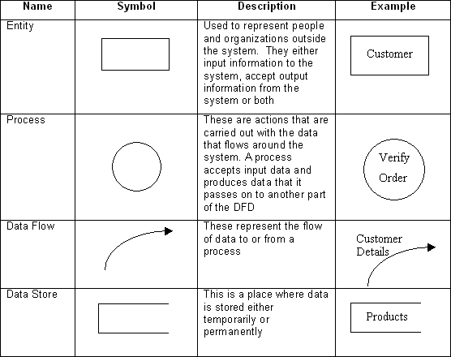

Data flow diagrams illustrate how data is processed by a system in terms of inputs and outputs.

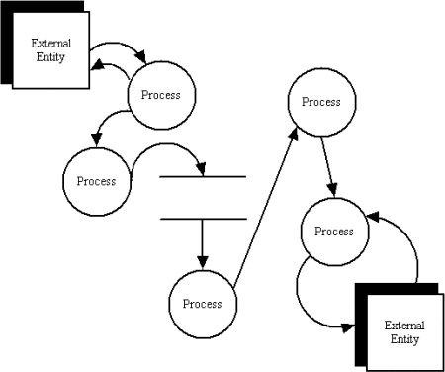

**Data Flow Diagram Layers**

Draw data flow diagrams in several nested layers. A single process node on a high level diagram can be expanded to show a more detailed data flow diagram. Draw the context diagram first, followed by various layers of data flow diagrams.

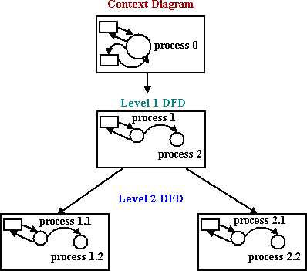

A **Structure Chart** (SC) in software engineering is a chart which shows the breakdown of a system to its lowest manageable levels. They are used in structured programming to arrange program modules into a tree. Each module is represented by a box, which contains the module's

name. The lines represent the connection and or ownership between activities and sub activities as they are used in organization charts. The tree structure visualizes the relationships between modules.

**Performance Instruction:**

**To draw DFD**

1. Identify various processes, data store, input, output etc. of the system and analyse it.
2. Use processes at various levels to draw the DFDs.

##### To draw structured Chart Diagram

1. Identify various modules, input, output etc. of the system.
2. Draw structured chart diagram describing it in form of levels.

#### Sample Output:

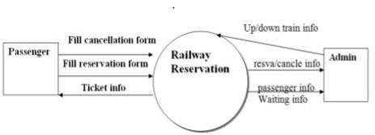

##### Context Diagram / Level 0 DFD

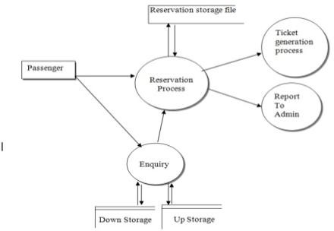

**Level 1 DFD**

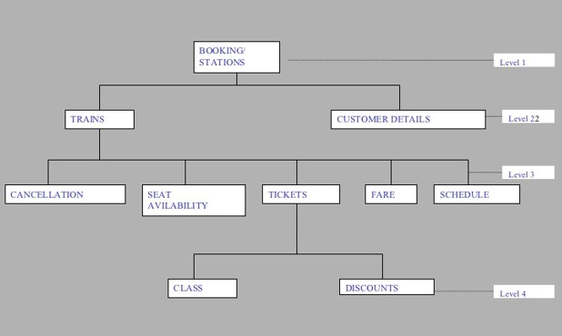

##### Structured Diagram

**Conclusion:** DFD and Structured Chart diagram was made successfully by following above steps.

#### Viva - Questions:

Q-1. Define DFD? What are different levels of DFD?

Q-2. Describe symbols used for constructing DFDs?

Q-3. Distinguish between a data flow diagram and a flow chart with example?

Q-4. Explain structured chart diagram?

Q-5. Describe symbols used for constructing structured chart diagram?

### Experiment 4.

**Aim:** To perform the user’s view analysis for the suggested system: Use case diagram.

**Description:** The use-case diagram can provide the user’s view for designing of the software product. And it can also be tested by matching up the requirements with the use-cases.

**When to Use:** Use Cases Diagrams

Use cases are used in almost every project. They are helpful in exposing requirements and Planning the project. During the initial stage of a project most use cases should be defined, but as the project continues more might become visible.

**Actors---**Are NOT part of the system – they represent anyone or anything that must interact with the system.

Only input information to the system. Only receive information from the system.

Both input to and receive information from the system.

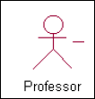

Represented in UML as a stickman.

##### Use Case

A sequence of transactions performed by a system that yields a measurable result of values for a particular actor

A use case typically represents a major piece of functionality that is complete from beginning to end. A use case must deliver something of value to an actor

##### Use Case Relationships Between actor and use case.

Association / Communication.

Arrow can be in either or both directions; arrow indicates who initiates communication.

##### Between use cases (generalization):

Uses: Where multiple use cases share pieces of same functionality.

**Performance Instruction**:

1. Identify various processes, use-cases, actors etc. of the system and analyze it.
2. Use processes at various levels and draw use case diagram.

#### Sample Output:

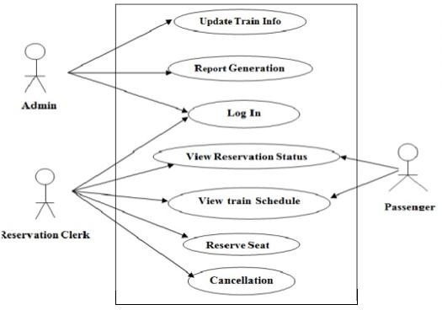

##### Use case Diagram

**Conclusion:** Use Case diagram was made successfully by following above steps.

#### Viva - Questions:

Q-1. Explain use case approach of requirement elicitation?

Q-2. Explain term: use-case, use-case scenarios, use-case diagrams?

Q-3. What are actors and use cases?

Q-4. Explain guidelines that should be kept in mind while creating use cases?

Q-5. Name the person who invented use case approach?

### Experiment 5.

**Aim:** To draw the structural view diagram for the system: Class diagram, object diagram.

**Description: Class diagrams** are widely used to describe the types of objects in a system and their relationships. Class diagrams model class structure and contents using design elements such as

classes, packages and objects. Class diagrams describe three different perspectives when designing a system, conceptual, specification, and implementation.

Classes are composed of three things: a name, attributes, and operations. Below is an example of a class:

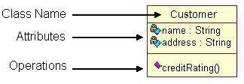

**Object diagrams** are derived from class diagrams so object diagrams are dependent upon class diagrams. Object diagrams represent an instance of a class diagram. The basic concepts are similar for class diagrams and object diagrams. Object diagrams also represent the static view of a system but this static view is a snapshot of the system at a particular moment.

Object diagrams are used to render a set of objects and their relationships as an instance.

#### Performance Instruction:

##### To draw class diagram

1. Identify various elements such as classes, member variables, member functions etc. of the class diagram
2. Draw the class diagram as per the norms

##### To draw object diagram

1. First, analyze the system and decide which instances have important data and association.
2. Second, consider only those instances, which will cover the functionality.
3. Third, make some optimization as the number of instances are unlimited.

#### Sample Output:

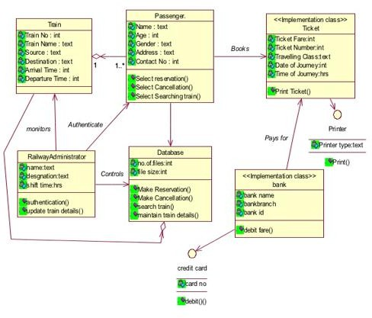

##### Class diagram

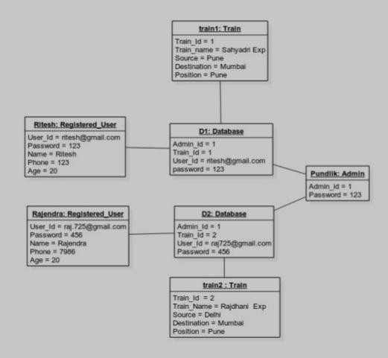

**Object Diagram**

**Conclusion:** Class diagram and Object diagram were made successfully by following above steps.

#### Viva - Questions:

Q-1. Explain class diagram?

Q-2. Explain symbols used in it?

Q-3. Explain four types of relationship used in class diagram?

Q-4. Explain terms classes, interfaces, collaborations and dependency?

Q-5. Explain object diagram?

### Experiment 6.

**Aim:** To draw the behavioral view diagram: State-chart diagram, Activity diagram

**Description:** State diagrams are used to describe the behavior of a system. State diagrams describe

all of the possible states of an object as events occur. Each diagram usually represents objects of a single class and tracks the different states of its objects through the system.

**State chart** diagrams represent the behavior of entities capable of dynamic behavior by specifying its response to the receipt of event instances.

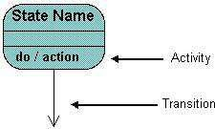

**Activity diagrams** describe the workflow behavior of a system. Activity diagrams are similar to state diagrams because activities are the state of doing something. The diagrams describe the state of activities by showing the sequence of activities performed. Activity diagrams can show activities that are conditional or parallel. Activity diagrams show the flow of activities through the system. Diagrams are read from top to bottom and have branches and forks to describe conditions and parallel activities. A fork is used when multiple activities are occurring at the same time. The diagram below shows a fork after activity1. This indicates that both activity2 and activity3 are occurring at the same time. After activity2 there is a branch. The branch describes what activities will take place based on a set of conditions. All branches at some point are followed by a merge to indicate the end of the conditional behavior started by that branch. After the merge all of the parallel activities must be combined by a join before transitioning into the final activity state.

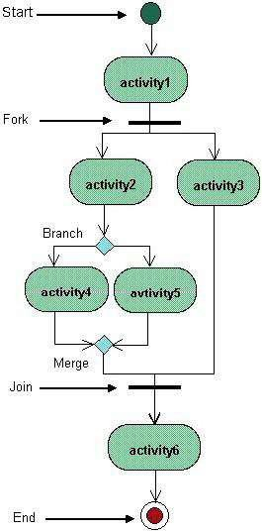

#### Performance Instruction:

##### To draw state chart diagram

1. Identify various elements states and their different transition of the state-chart diagram
2. Draw the state-chart diagram as per the norms.

##### To draw activity diagram

1. Identify various elements such as different activity their boundaries etc. of the activity diagram
2. Draw the activity diagram as per the norms.

#### Sample Output:

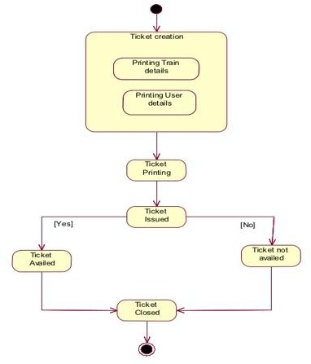

##### State Chart Diagram

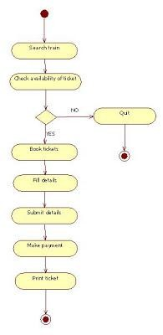

**Activity diagram for booking ticket**

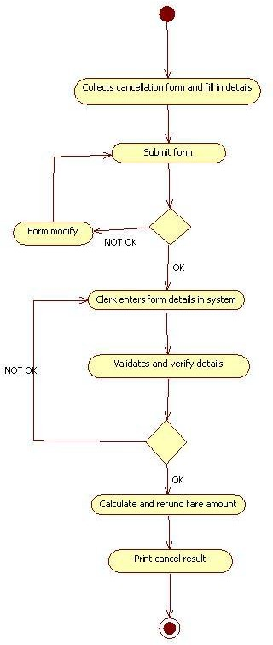

##### Activity Diagram for cancel ticket

**Conclusion:** State Chart and Activity diagram were made successfully by following above steps.

#### Viva - Questions:

Q-1. How activity diagram explains behavioral view of system?

Q-2. Explain steps followed to construct activity diagram?

Q-3. How state chart diagram explains behavioral view of system?

Q-4. Explain steps followed to construct state chart diagram?’

Q-5. Explain symbols used to construct these diagrams?

### Experiment 7.

**Aim:** To perform the behavioral view diagram for the suggested system: Sequence diagram, Collaboration diagram.

**Description: Sequence diagrams** show potential interactions between objects in the system being defined. Normally these are specified as part of a use case or use case flow and show how the use case will be implemented in the system. They include:

**#Objects** - oblong boxes or actors at the top - either named or just shown as belonging to a class, from, or to which messages are sent to other objects.

|  |  |
| --- | --- |
| # | **Messages** - solid lines for calls and dotted lines for data returns, showing the messages that are sent between objects including the order of the messages which is from the  top to the bottom of the diagram. |
|  | **#Object lifelines** - dotted vertical lines showing the lifetime of the objects. |
|  | **#Activation** - the vertical oblong boxes on the object lifelines showing the thread of control in a synchronous system.  Sequence diagrams show a detailed flow for a specific use case or even just part of a specific use case. They are almost self-explanatory; they show the calls between the different objects in their sequence and can show, at a detailed level, different calls to different objects. A sequence diagram has two dimensions: The vertical dimension shows the sequence of messages/calls in the time order that they occur; the horizontal  dimension shows the object instances to which the messages are sent. |

##### Collaboration Diagram

They are the same as sequence diagrams but without a time axis:

* Their message arrows are numbered to show the sequence of message sending.
* They are less complex and less descriptive than sequence diagrams.
* These diagrams are very useful during design because you can figure out how objects communicate with each other.

**Performance Instruction:**

##### To draw Sequence Diagram

1. Identify the class instances (objects) by putting each class instance inside a box.
2. If a class instance sends a message to another class instance, draw a line with an open arrowhead pointing to the receiving class instance; place the name of the message/method above the line.
3. Optionally, for important messages, you can draw a dotted line with an arrowhead pointing back to the originating class instance; label the return value above the dotted line.

##### To draw collaboration Diagram

1. By simply pressing combination of keys, we can design collaboration diagram from sequence diagram.

#### Sample Output:

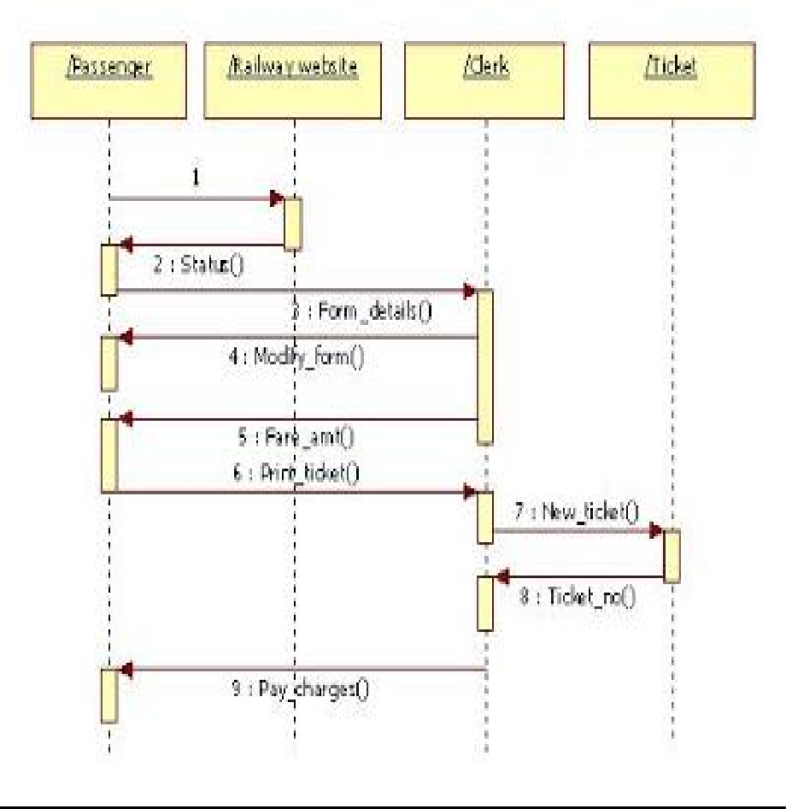

##### Sequence Diagram for booking ticket

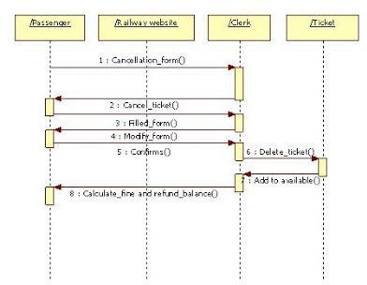

**Sequence Diagram for cancel diagram**

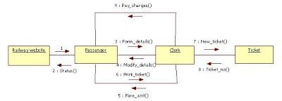

##### Collaboration Diagram for booking ticket

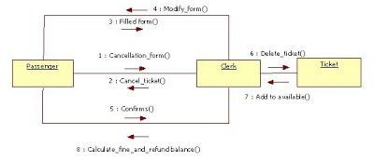

**Collaboration Diagram for cancel ticket**

**Conclusion:** Sequence diagram and Collaboration Diagram were made successfully by following above steps.

#### Viva - Questions:

Q-1. Explain use of sequence diagram?

Q-2. Explain steps to draw sequence diagram?

Q-3. Explain need of collaboration diagram?

Q-4. Explain steps to draw collaboration diagram?

Q-5. Explain terms- entity objects, interface objects and control objects?

### Experiment 8.

**Aim:** To perform the implementation view diagram: Component diagram for the system.

**Description:** A component diagram provides a physical view of the system. Its purpose is to show the dependencies that the software has on the other software components (e.g., software libraries) in the system. The diagram can be shown at a very high level, with just the large-grain components, or it can be shown at the component package level. [Note: The phrase component package level is a programming language-neutral way of referring to class container levels such as .NET's namespaces (e.g., System.Web.UI) or Java's packages (e.g., java.util).

Basic Component Diagram Symbols and Notations

***Component***

A component is a logical unit block of the system, a slightly higher abstraction than classes. It is represented as a rectangle with a smaller rectangle in the upper right corner with tabs or the word written above the name of the component to help distinguish it from a class.

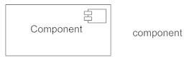

###### Interface

An interface (small circle or semi-circle on a stick) describes a group of operations used (required) or created (provided) by components. A full circle represents an interface created or provided by the component. A semi-circle represents a required interface, like a person's input.

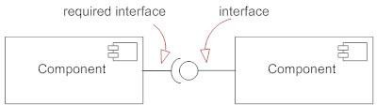

###### Dependencies

Draw dependencies among components using dashed arrows.

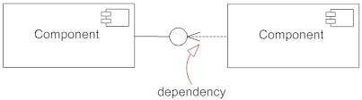

###### Port

Ports are represented using a square along the edge of the system or a component. A port is often used to help expose required and provided interfaces of a component.

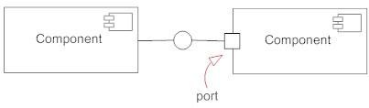

**Performance Instruction:**

**To Draw a Component Diagram**

* Take stock of everything needed to implement the planned system. For example, for a simple e-commerce system, you'll need components that describe products, orders, and customer accounts.
* Create a visual for each of the components.
* Describe the organization and relationships between components using interfaces, ports, and dependencies.

#### Sample Output:

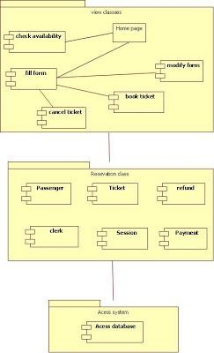

##### Component Diagram

**Conclusion:** Component diagram was made successfully by following above steps.

#### Viva - Questions:

Q-1. Explain term component diagram?

Q-2. Component diagram explains which view of system?

Q-3. Explain steps to draw component diagram?

Q-4. What is benefit of drawing component diagram?

Q-5. Explain symbols used to draw component diagram?

### Experiment 9.

**Aim:** To perform the environmental view diagram: Deployment diagram for the system.

**Description:** The deployment diagram shows how a system will be physically deployed in the hardware environment. Its purpose is to show where the different components of the system will physically run and how they will communicate with each other. Since the diagram models the physical runtime, a system's production staff will make considerable use of this diagram.

The notation in a deployment diagram includes the notation elements used in a component diagram, with a couple of additions, including the concept of a node. A node represents either a physical machine or a virtual machine node (e.g., a mainframe node). To model a node, simply draw a three-dimensional cube with the name of the node at the top of the cube.

#### Performance Instruction:

To create a deployment diagram 1)Identify component

1. Add shapes 3)Connect Nodes 4)Format arrows

#### Sample Output:

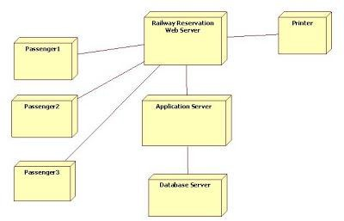

##### Deployment Diagram

**Conclusion:** Deployment diagram was made successfully by following above steps.

#### Viva - Questions:

Q-1. What is deployment diagram?

Q-2. Deployment diagram explains which view of system?

Q-3. Explain steps to draw deployment diagram?

Q-4. Explain symbols used to draw deployment diagram?

Q-5. What is benefit of drawing deployment diagram?

### Experiment 10.

**Aim:** To perform various testing using the testing tool unit testing, integration testing for a sample code of the suggested system.

#### Description:

“Testing is the process of executing a program with the intent of finding errors.” The purpose of software testing is

1. To demonstrate that the product performs each function intended.
2. To demonstrate that the internal operation of the product performs according to specification and all internal components have been adequately exercised.
3. To increase our confidence in the proper functioning of the software.
4. To show the product is free from defect.
5. All of the above.

**Unit Testing—**Checks each coded module for the presence of bugs. Unit testing’s purpose is to ensure that each as- built module behaves according to its specification defined during detailed design.

**Integration Testing** Interconnects sets of previously tested modules to ensure that the sets

behave as well as they did as independently tested modules. Integration testing’s purpose is to ensure that each as-built component behaves according to its specification defined during preliminary design.

#### Performance Instruction:

**Unit test planning—**Generate plans and procedures to test each module independently and thoroughly.

**Integration Test Planning—**Generate plans and procedures to effect orderly system integration.

#### Sample Problem Statement:

Consider a program for the determination of the nature of roots of a quadratic equation. Its input is a triple of positive integers (say a,b,c) and values may be from interval [0,100]. The program output may have one of the following words. [Not a quadratic equation; Real roots; Imaginary roots; Equal roots] Design the boundary value test cases

#### Sample Output:

Quadratic equation will be of type: ax2+bx+c=0

Roots are real if (b2-4ac)>0 Roots are imaginary if (b2-4ac)

Roots are equal if (b2-4ac)=0 Equation is not quadratic if a=0 The boundary value test cases are :

|  |  |  |  |  |
| --- | --- | --- | --- | --- |
| **Test Case** | **a** | **b** | **c** | **Expected Output** |
| 1 | 0 | 50 | 50 | Not Quadratic |
| 2 | 1 | 50 | 50 | Real Roots |
| 3 | 50 | 50 | 50 | Imaginary Roots |
| 4 | 99 | 50 | 50 | Imaginary Roots |
| 5 | 100 | 50 | 50 | Imaginary Roots |
| 6 | 50 | 0 | 50 | Imaginary Roots |
| 7 | 50 | 1 | 50 | Imaginary Roots |
| 8 | 50 | 99 | 50 | Imaginary Roots |
| 9 | 50 | 100 | 50 | Equal roots |
| 10 | 50 | 50 | 0 | Real Roots |
| 11 | 50 | 50 | 1 | Real roots |
| 12 | 50 | 50 | 99 | Imaginary Roots |
| 13 | 50 | 50 | 100 | Imaginary Roots |

The robust test cases are:

|  |  |  |  |  |
| --- | --- | --- | --- | --- |
| ***Test case*** | ***a*** | ***b*** | ***c*** | ***Expected Output*** |
| 1 | -1 | 50 | 50 | Invalid input` |
| 2 | 0 | 50 | 50 | Not quadratic equation |
| 3 | 1 | 50 | 50 | Real roots |
| 4 | 50 | 50 | 50 | Imaginary roots |
| 5 | 99 | 50 | 50 | Imaginary roots |
| 6 | 100 | 50 | 50 | Imaginary roots |

|  |  |  |  |  |
| --- | --- | --- | --- | --- |
| 7 | 101 | 50 | 50 | Invalid input |
| 8 | 50 | -1 | 50 | Invalid input |
| 9 | 50 | 0 | 50 | Imaginary roots |
| 10 | 50 | 1 | 50 | Imaginary roots |
| 11 | 50 | 99 | 50 | Imaginary roots |
| 12 | 50 | 100 | 50 | Equal roots |
| 13 | 50 | 101 | 50 | Invalid input |
| 14 | 50 | 50 | -1 | Invalid input |
| 15 | 50 | 50 | 0 | Real roots |
| 16 | 50 | 50 | 1 | Real roots |
| 17 | 50 | 50 | 99 | Imaginary roots |
| 18 | 50 | 50 | 100 | Imaginary roots |
| 19 | 50 | 50 | 101 | Invalid input |

**Conclusion:** Test Cases for given code was made successfully.

#### Viva - Questions:

Q-1. what is software testing?

Q-2. Explain terms unit testing and integration testing?

Q-3. Why should we test? Who should do the testing?

Q-4. Discuss limitation of testing?

Q-5. Explain term functional and structural testing?

### Experiment 11.

**Aim:** To Perform Estimation of effort using FP Estimation for chosen system.

**Description:** A **function point** is a "unit of measurement" to express the amount of business functionality an information system (as a product) provides to a user. Function points are used to compute a functional size measurement (FSM) of software.

The principle of Albrecht’s function point analysis (FPA) is that a system is decomposed into functional units.

1. Inputs: information entering the system
2. Outputs: information leaving the system
3. Enquiries: requests for instant access to information
4. Internal logical files: information held within the system
5. External interface files: information held by other system that is used by the system being analyzed.

The FPA functional units are shown in figure given below:

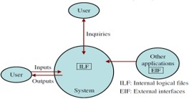

The five functional units are divided in two categories:

1. Data function types
   * Internal Logical Files (ILF): A user identifiable group of logical related data or control information maintained within the system.
   * External Interface files (EIF): A user identifiable group of logically related data or control information referenced by the system, but maintained within another system. This means that EIF counted for one system, may be an ILF in another system.
2. Transactional function types
   * External Input (EI): An EI processes data or control information that comes from outside the system. The EI is an elementary process, which is the smallest unit of activity that is meaningful to the end user in the business.
   * External Output (EO): An EO is an elementary process that generate data or control information to be sent outside the system.
   * External Inquiry (EQ): An EQ is an elementary process that is made up to an input-output combination that results in data retrieval.

##### Special features

* + Function point approach is independent of the language, tools, or methodologies used for implementation; i.e. they do not take into consideration programming languages, data base management systems, processing hardware or any other data base technology.
  + Function points can be estimated from requirement specification or design specification, thus making it possible to estimate development efforts in early phases of development
  + Function points are directly linked to the statement of requirements; any change of requirements can easily be followed by a re-estimate.
  + Function points are based on the system user’s external view of the system, non-technical users of the software system have a better understanding of what function points are measuring.

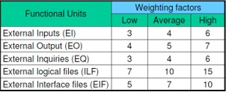

**Performance Instruction:**

1.Observe functional units and their weighting factors. 2.Compute them in formula to find value of UFP count. 3.Find value of FP by using formula.

#### Sample Problem Statement:

Consider a project with the following parameters. (i)External Inputs:

(a) 10 with low complexity (b)15 with average complexity

(c) 17 with high complexity

1. External Outputs:

(a) 6 with low complexity (b)13 with high complexity

1. External Inquiries:

(a)3 with low complexity (b)4 with average complexity (c)2 with high complexity

1. Internal logical files:

(a) 2 with average complexity (b)1 with high complexity

1. External Interface files:
2. 9 with low complexity

In addition to above, system requires

* 1. Significant data communication
  2. Performance is very critical
  3. Designed code may be moderately reusable
  4. System is not designed for multiple installation in different organizations.

Other complexity adjustment factors are treated as average. Compute the function points for the project.

**Sample Solution:** Unadjusted function points may be counted using below table

|  |  |  |  |  |
| --- | --- | --- | --- | --- |
| Functional Units | Count | Complexity | Complexity  Totals | Functional Unit  Totals |
| External Inputs | 10 | Low * 3 | 30 |  |
| (EIs) | 15 | Average * 4 | 60 |  |
|  | 17 | High * 6 | 102 | 192 |
| External Outputs | 6 | Low * 4 | 24 |  |
| (EOs) | 0 | Average * 5 | 0 |  |
|  | 13 | High * 7 | 91 | 115 |
| External | 3 | Low * 3 | 9 |  |
| Inquiries (EQs) | 4 | Average * 4 | 16 |  |
|  | 2 | High * 6 | 12 | 37 |
| External logic | 0 | Low * 7 | 0 |  |
| Files (ILFs) | 2 | Average * 10 | 20 |  |
|  | 1 | High * 15 | 15 | 35 |
| External | 9 | Low * 5 | 45 |  |
| Interface Files | 0 | Average * 7 | 0 |  |
| (EIFs) | 0 | High * 10 | 0 | 45 |
| Total Unadjusted Function Point Count = 424 | | | | |

Σ Fi = 3+4+3+5+3+3+3+3+3+3+2+3+0+3=41 CAF = (0.65 + 0.01* Σ Fi)

= (0.65 + 0.01* 41)

= 1.06

FP = UFP * CAF

= 424*1.06

= 449.44

Hence FP = 449

**Conclusion:** FP estimation was done successfully.

#### Viva - Questions:

Q-1. Explain five functional units of functional point analysis(FPA)?

Q-2. Explain special features of FPA?

Q-3. Explain three weighting factors of functional units?

Q-4. Explain term unadjusted function point count (UFP)?

Q-5. What are uses of function point?

### Experiment 12.

**Aim:** To Prepare time line chart/Gantt Chart/PERT Chart for selected software project. **Description:** A **Gantt chart** is a graphical depiction for planning and scheduling projects. It breaks a project into smaller pieces of tasks with each of these spread out over time. With it, you can see task dependencies, scheduling constraints, duration of each task and percent complete.

In a **Gantt Chart**, each activity is represented by a bar; the position and length of the bar reflects the start date, duration and end date of the activity. The milestone is represented by a triangle, and the relationship is always shown with an arrow.

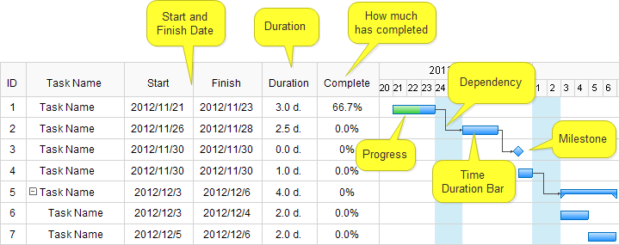

##### Gantt Chart

[PERT](https://www.edrawsoft.com/PERT-Chart.php) stands for **Program Evaluation Review Technique**. It was introduced by the United

States Navy in the 1950s. Pert chart is also a project management tool used to plan tasks within a project – making it easier to schedule and coordinate team members accomplishing the work.

Pert chart was initially developed to simplify the planning and scheduling of large and complex projects. Pert chart looks like a flowchart. It uses boxes and arrows to show the subtasks and their dependencies.

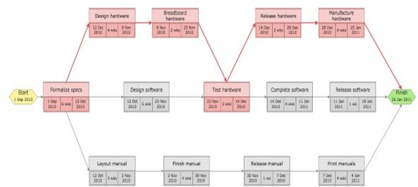

**PERT Chart**

**Performance Instruction:**

##### To Create a Gantt Chart

1. **Create a Task Table**

List each task in your project in start date order from beginning to end. Include the task name, start date, duration, and end date.

##### Build a Bar Chart

Click in the empty Series name: form field first, then click on the table cell that reads Start Date.

##### To Create a PERT Chart.

1. Create a Text Box.
2. With the text box still selected, go to the Format tab under Drawing Tools.
3. Click on the inside of the text box and begin entering any information for a single task.

#### Sample Output:

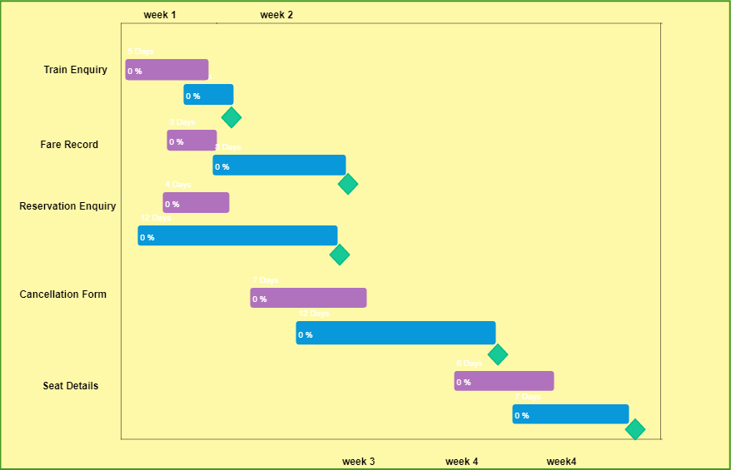

##### Gantt Chart

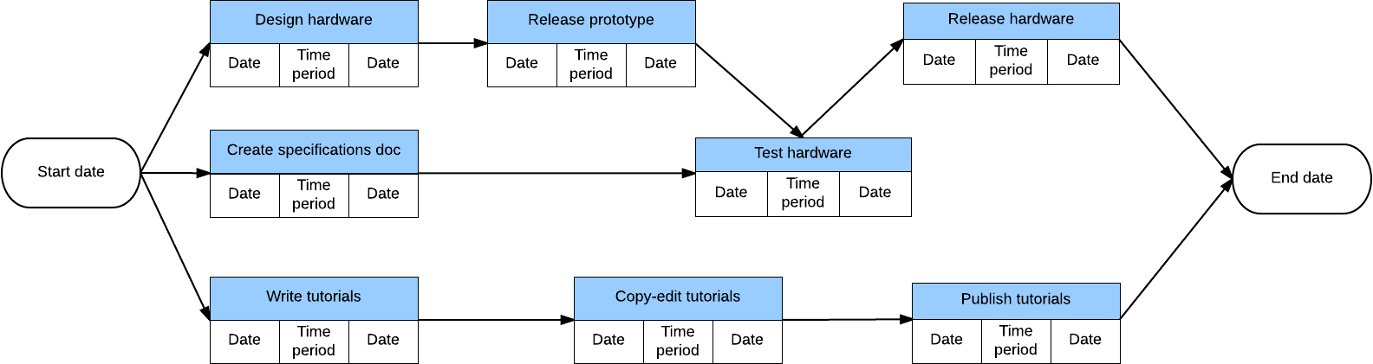

**PERT Chart**

**Conclusion:** Gantt chart and PERT chart were made successfully.

#### Viva - Questions:

Q-1. Explain term Gantt chart?

Q-2. Explain term PERT chart?

Q-3. What is advantage of using PERT chart?

Q-4. What are advantages of using Gantt chart?

Q-5. What are limitations of Gantt chart?

# Experiments beyond the syllabus

### Experiment 1.

**Aim:** To design a flow chart for chosen system.

**Description:** A **flowchart** is a type of diagram that represents an algorithm, workflow or process, showing the steps as boxes of various kinds, and their order by connecting them with arrows. This diagrammatic representation illustrates a solution model to a given problem.

Flowcharts are used in analyzing, designing, documenting or managing a process or program in various fields.

Symbols used in designing flow chart:

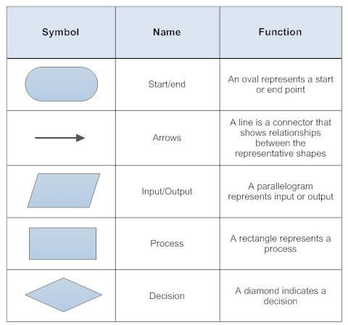

#### Performance Instruction:

1. Identify various processes, input/output and decision making statement of the system And analyze it.
2. Use them to draw flow chart.

#### Sample Output:

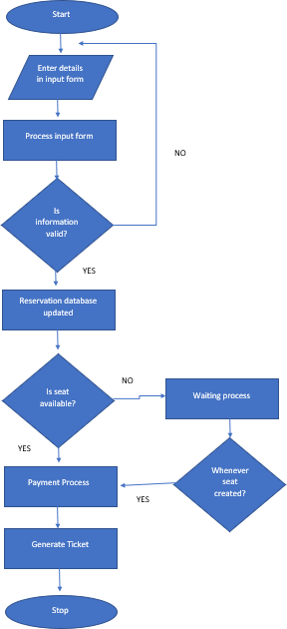

**Conclusion:** Flow chart was made successfully.

#### Viva - Questions:

Q-1. What is a flow chart?

Q-2. Explain symbols used to design flow chart?

Q-3. What is benefit of designing a flow chart?

Q-4. At which stage of designing it is designed?

Q-5. Is there any limitation of drawing it?

### Experiment 2.

**Aim:** To draw ER Diagram for chosen system.

**Description:** An entity relationship model*, also called an* entity-relationship (ER) diagram*, is a* graphical representation of entities and their relationships to each other, typically used in computing in regard to the organization of data within databases or information systems. An entity is a piece of data-an object or concept about which data is stored.

###### Relationships Between Entities

A relationship is how the data is shared between entities. There are three types of relationships between entities:

###### One-to-One

One-to-one entity relationship diagramOne instance of an entity (A) is associated with one other instance of another entity (B). For example, in a database of employees, each employee name (A) is associated with only one social security number (B).

###### One-to-Many

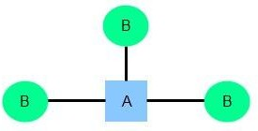One instance of an entity (A) is associated with zero, one or many instances of another entity (B), but for one instance of entity B there is only one instance of entity A. For example, for a company with all employees working in one building, the building name (A) is associated with many different employees (B), but those employees all share the same singular association with entity A.

###### Many-to-Many

One instance of an entity (A) is associated with one, zero or many instances of another entity (B), and one instance of entity B is associated with one, zero or many instances of entity A. For example, for a company in which all of its employees work on multiple projects, each instance of an employee (A) is associated with many instances of a project (B), and at the same time, each instance of a project (B) has multiple employees (A) associated with it.

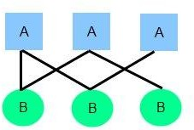

**Symbols used to draw ER diagram:**

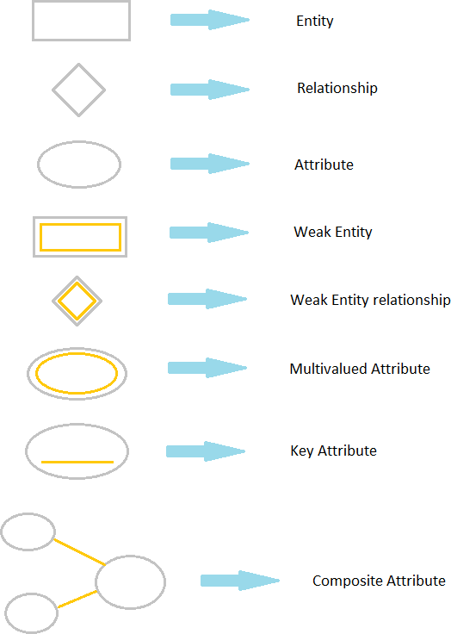

**Performance Instruction:**

1. Identify all entities and their attributes.
2. Identify weak entities, attributes and their identifying relationship.
3. Design ER diagram according to norms.
4. Imply cardinalities on diagram.

#### Sample Output:

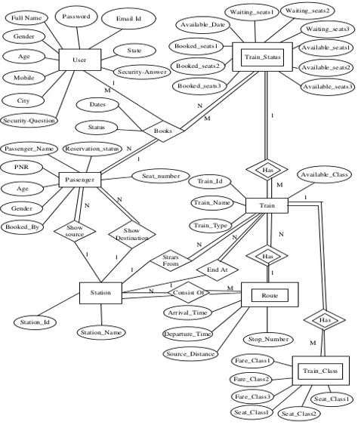

##### ER diagram for Railway Reservation System

**Conclusion:** ER diagram was made successfully.

#### Viva - Questions:

Q-1. Explain ER diagram?

Q-2. What is entity? Explain strong and week entity?

Q-3. What is attributes? Explain different types of attributes?

Q-4. Explain three types of relationship?

Q-5. what is cardinality?